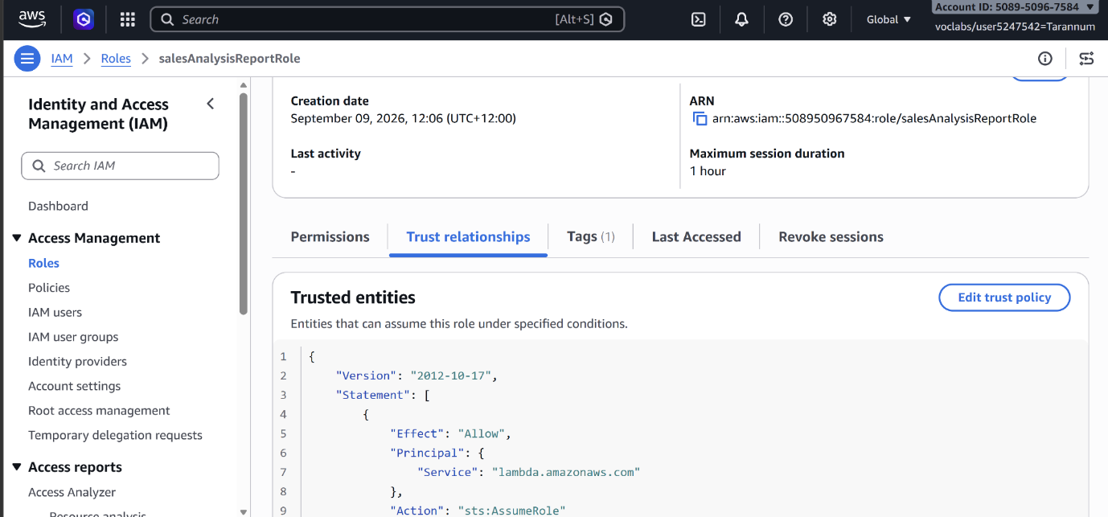
4 policies attached
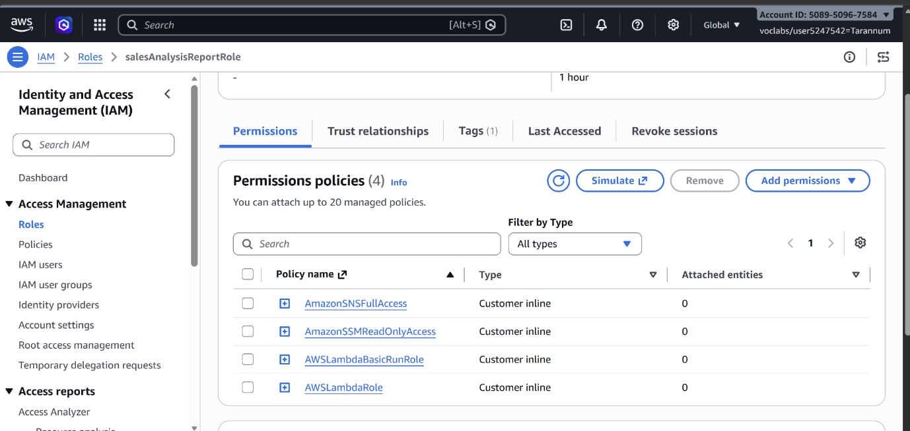
- AmazonSNSFullAccess: provides full access to Amazon Simple Notification Service (Amazon SNS) resources.
- AmazonSSMReadOnlyAccess: provides read-only access to AWS Systems Manager resources.
- AWSLambdaBasicRunRole: provides write permissions to CloudWatch logs (required by every Lambda function).
- AWSLambdaRole: allows a Lambda function to invoke another Lambda function.
This role will be used by the sales analysis report lambda function you will create later in this exercise.
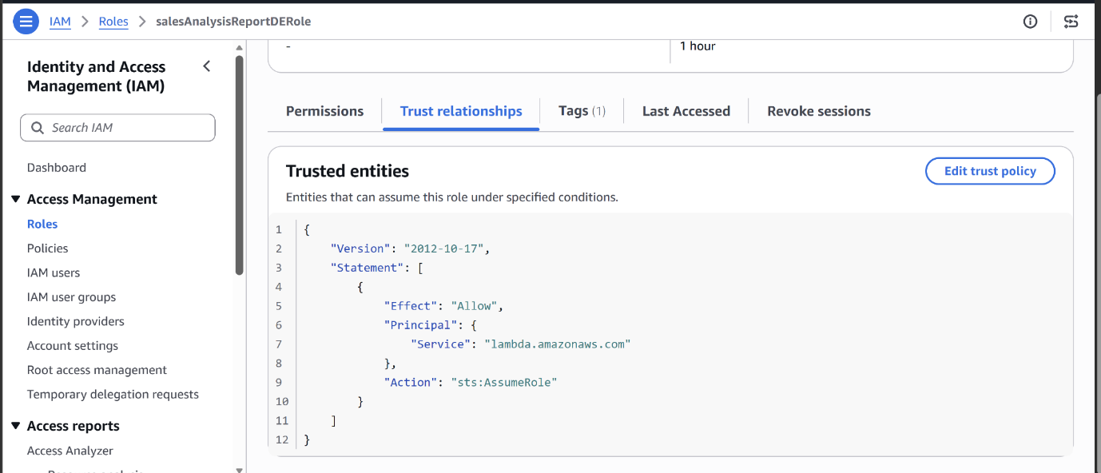
2 policies
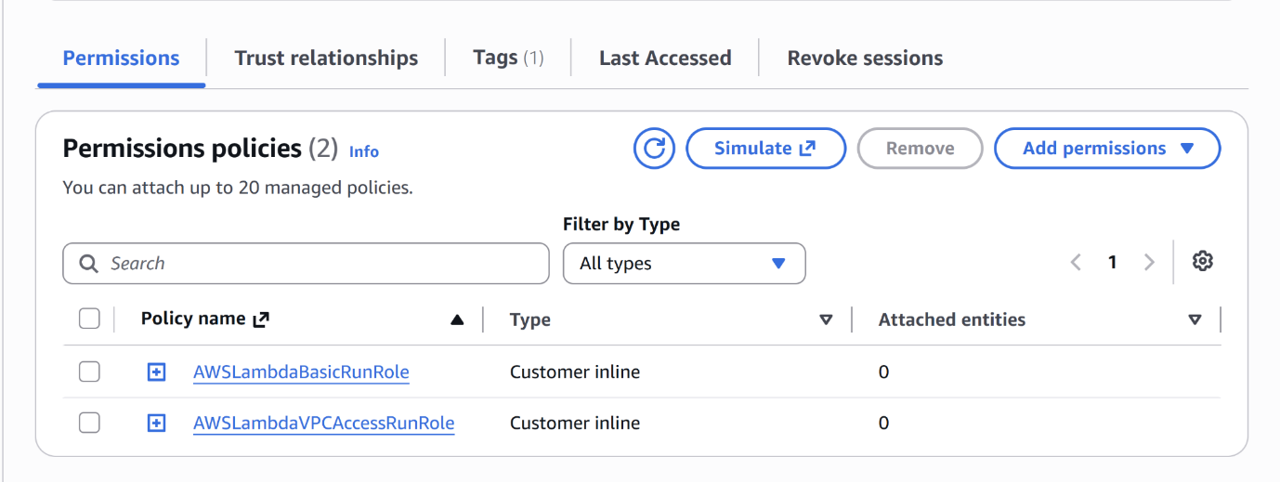
Permissions granted to this role:
- AWSLambdaBasicRunRole: provides write permissions to CloudWatch logs.
- AWSLambdaVPCAccessRunRole: provides permissions to manage elastic network interfaces to connect a function to a VPC.
This role will be used by the salesAnalysisReportDataExtractor Lambda function you will create next.

Create a Lambda layer and a data extractor Lambda function
salesAnalysisReportDataExtractor is a Python implementation of a Lambda function that makes use of the PyMySQL open source client library to access the MySQL Mom & Pop Café database. This library has been packaged into pymysql-0.9.3.zip.

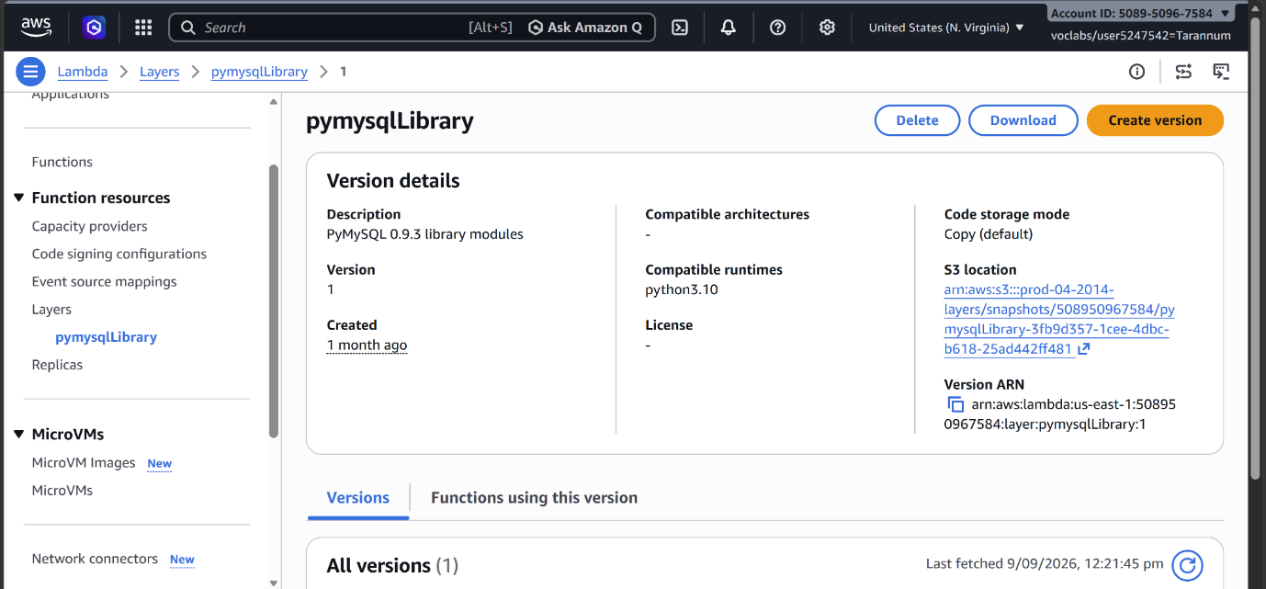
A Lambda Layer
Create the data extractor Lambda function
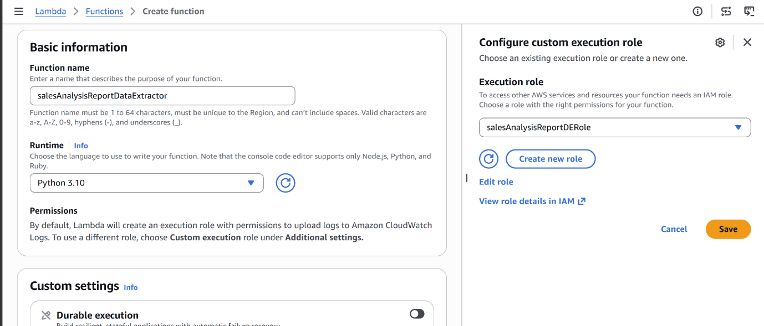

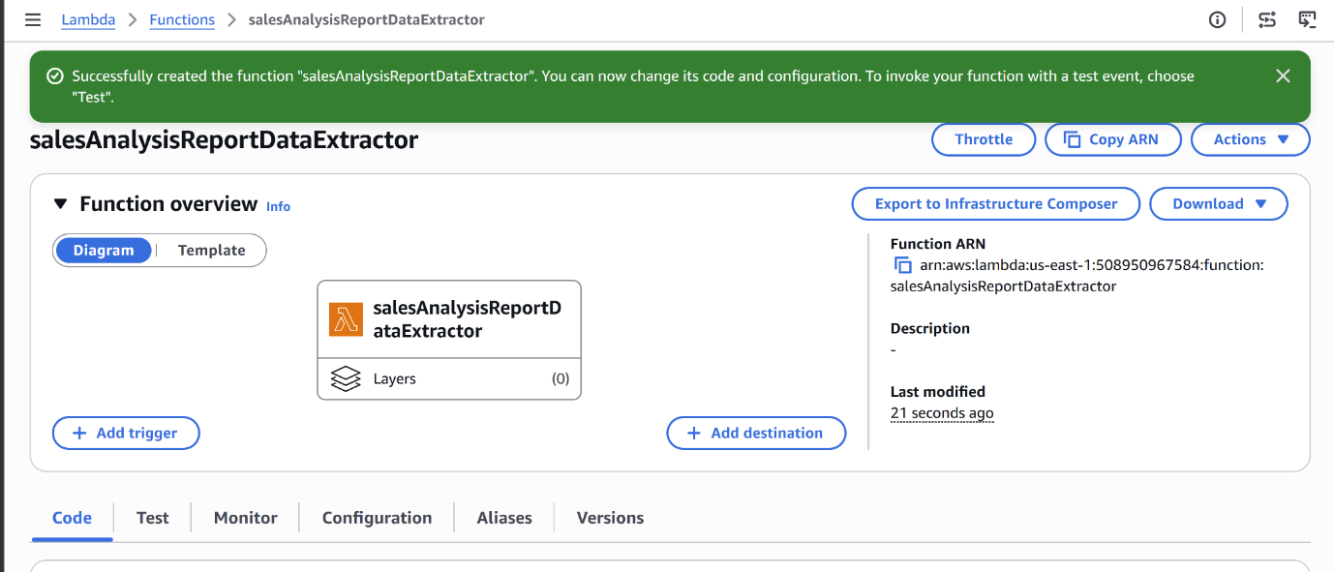
Add the Lambda Layer to the function
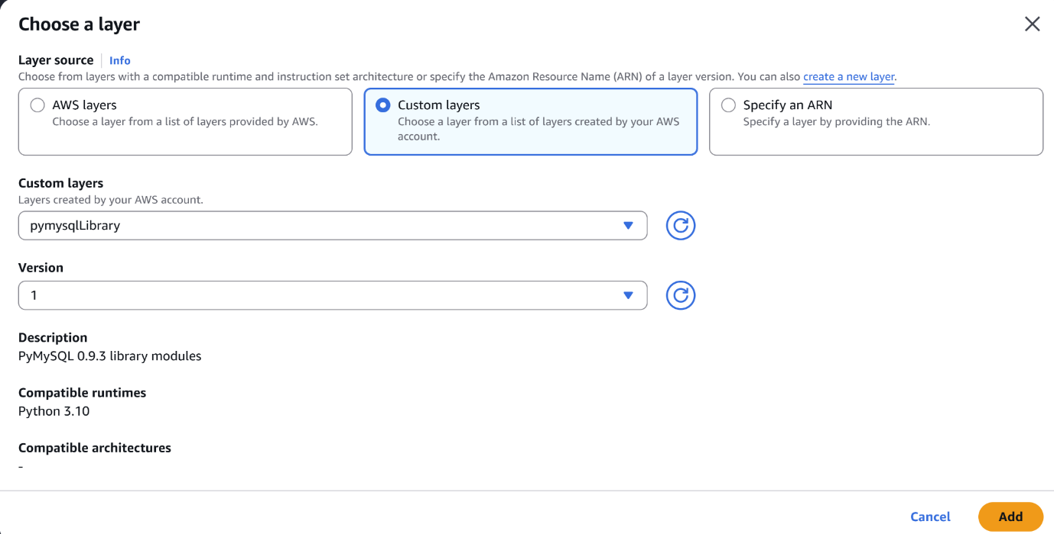

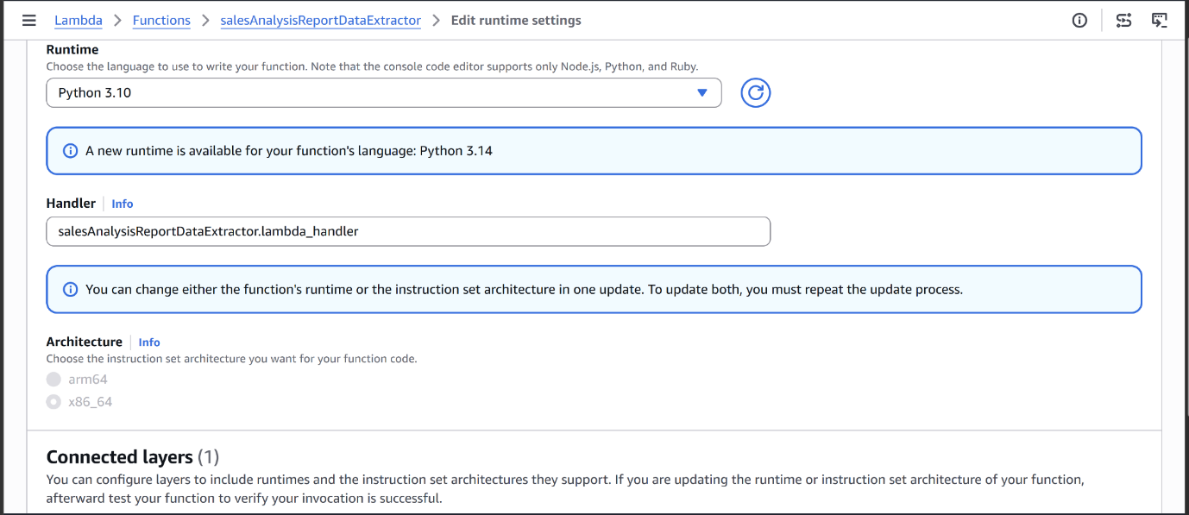
Handler

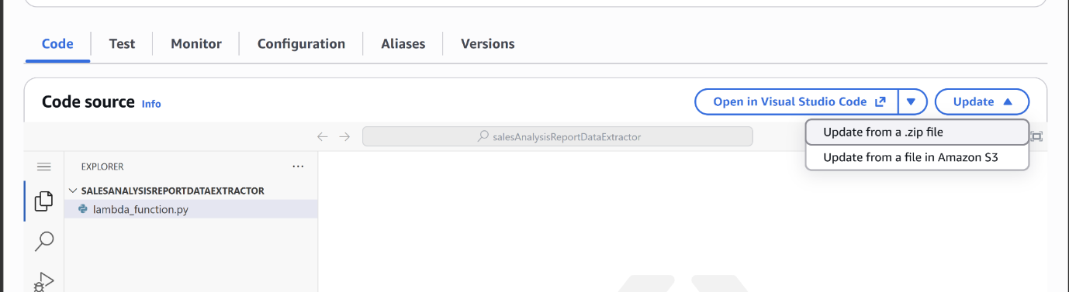

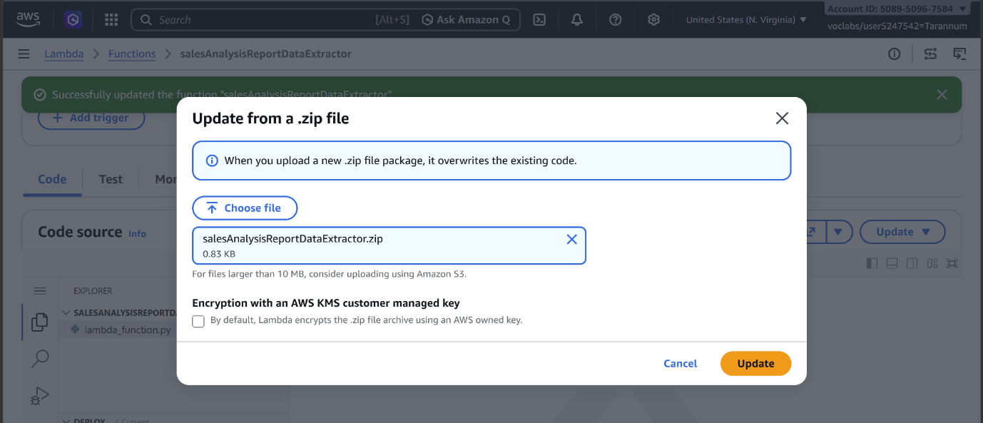

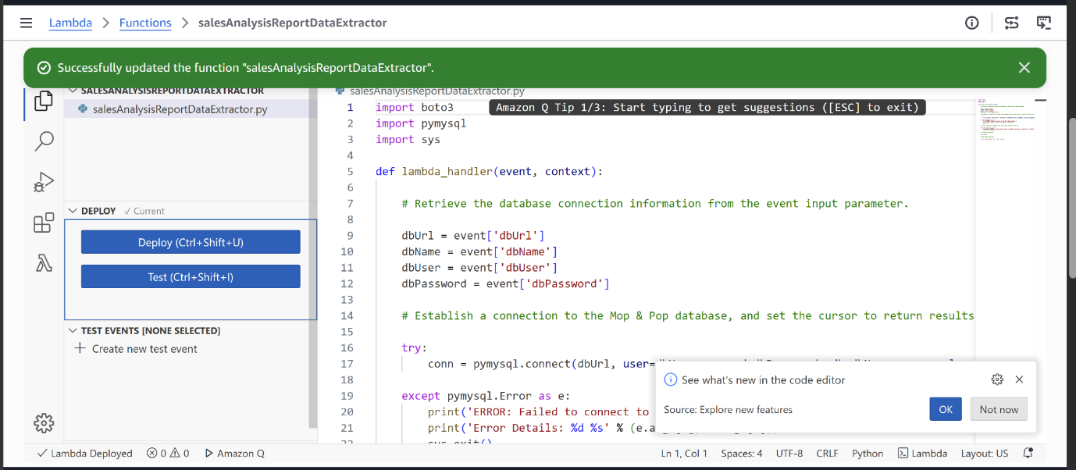

This Python code is an AWS Lambda function designed to connect to a MySQL database, run a sales report query, and return the aggregated results

Configure network settings for the function
The function requires network access to the Mom & Pop Café database which runs in an EC2 LAMP instance. Therefore, you need to specify the instance’s VPC, subnet and security group information in the function’s configuration.
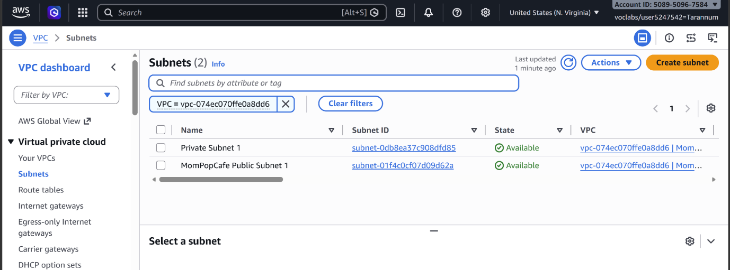
Its subnet MompopCafe Public Subnet1
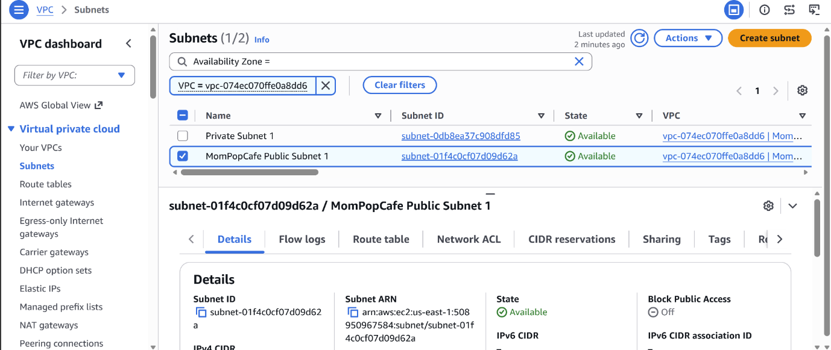

Security Group
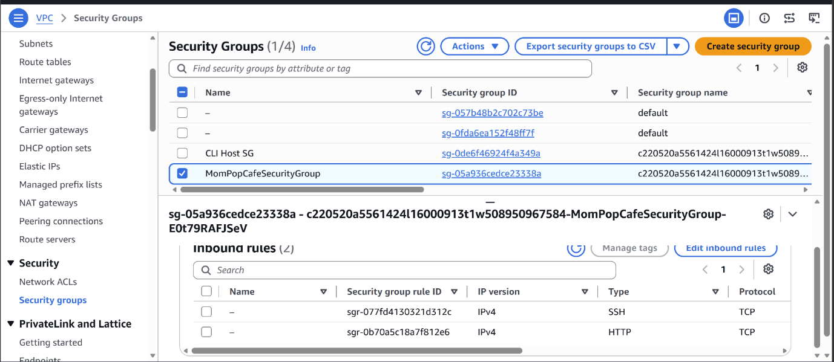

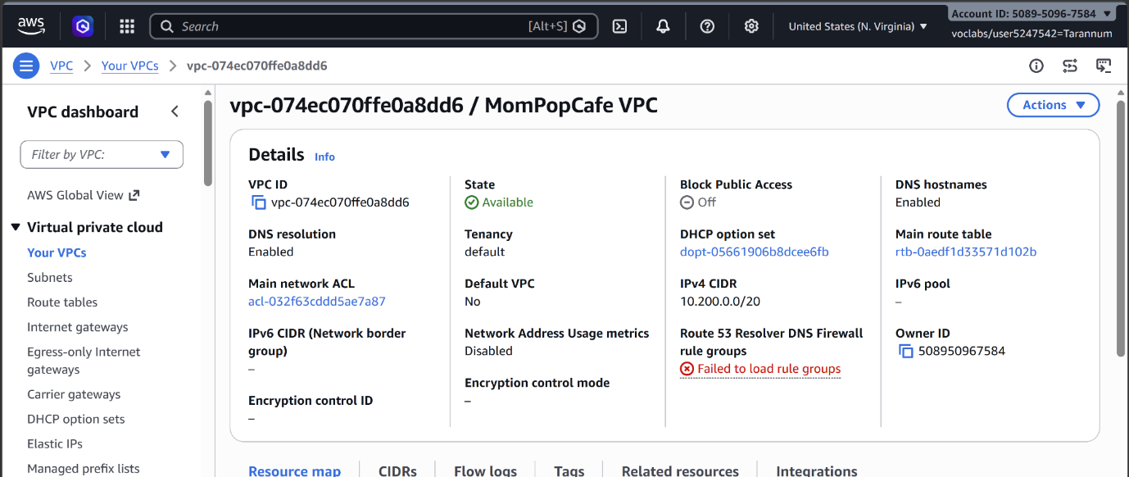
For the Lambda
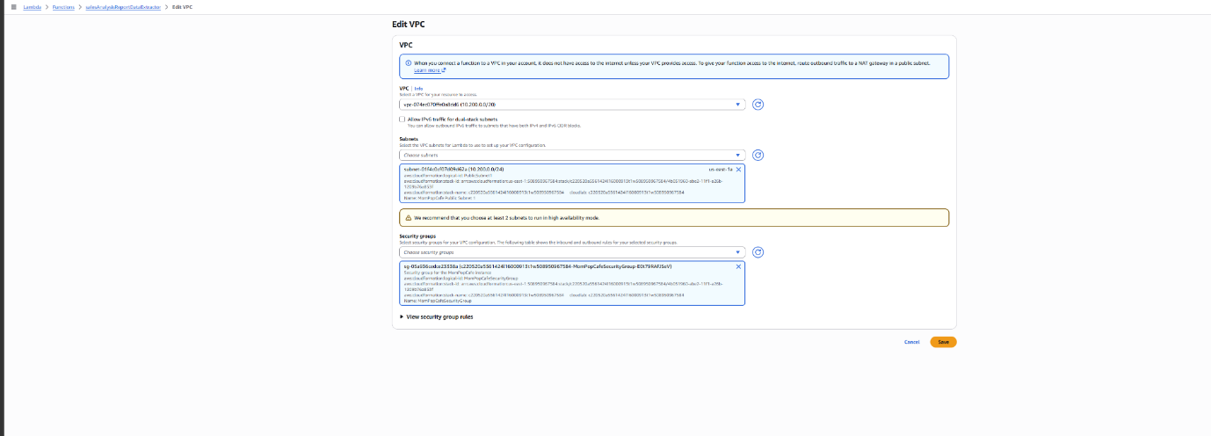

Configure network settings for the function

Test the data extractor Lambda function
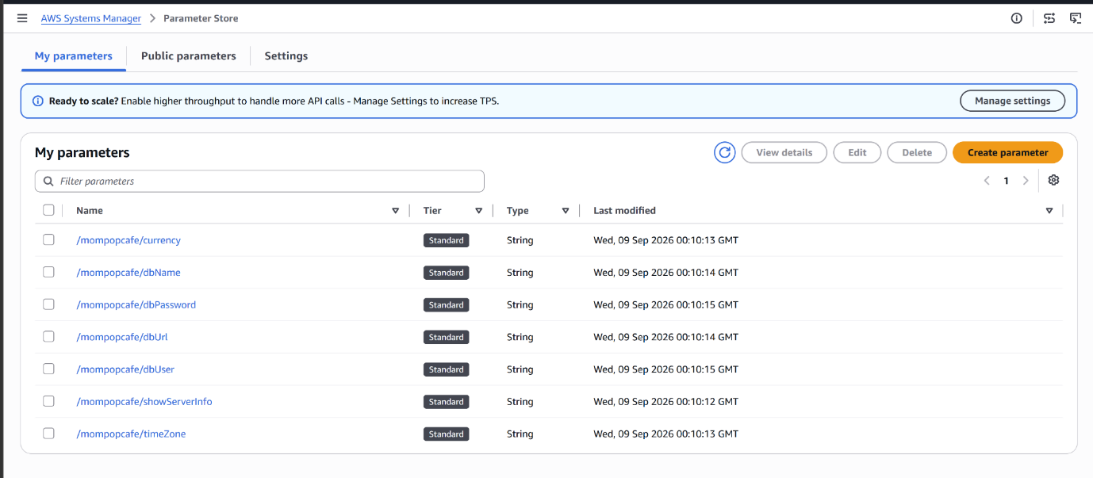

In system Manager the parameter store
In AWS Systems Manager Parameter Store page lists configuration settings and secrets specifically for your "Mom & Pop" cafe application (/mompopcafe/...).
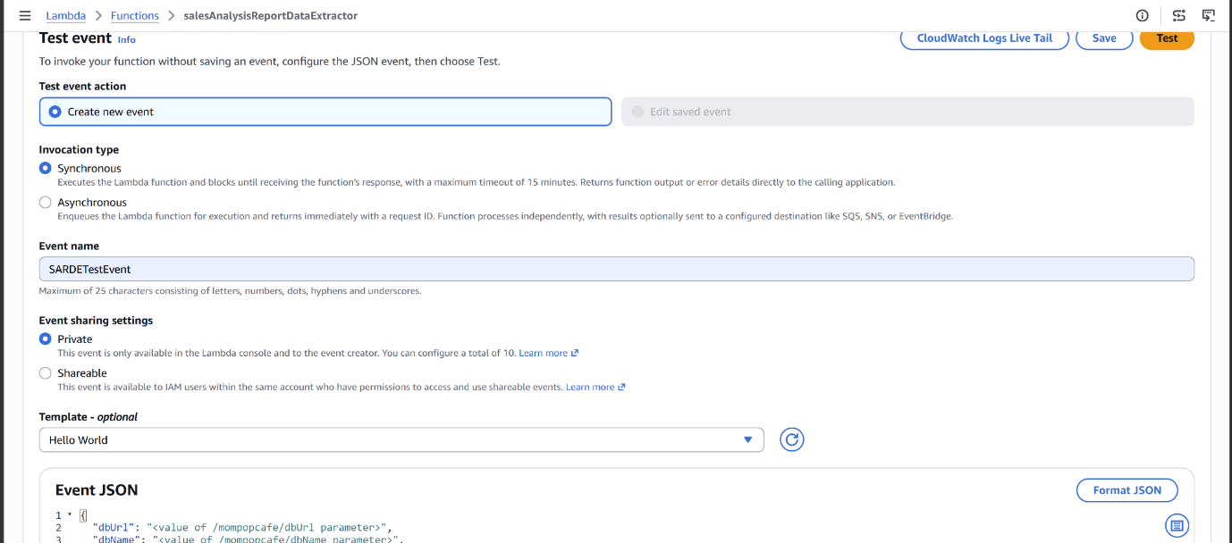Test the event
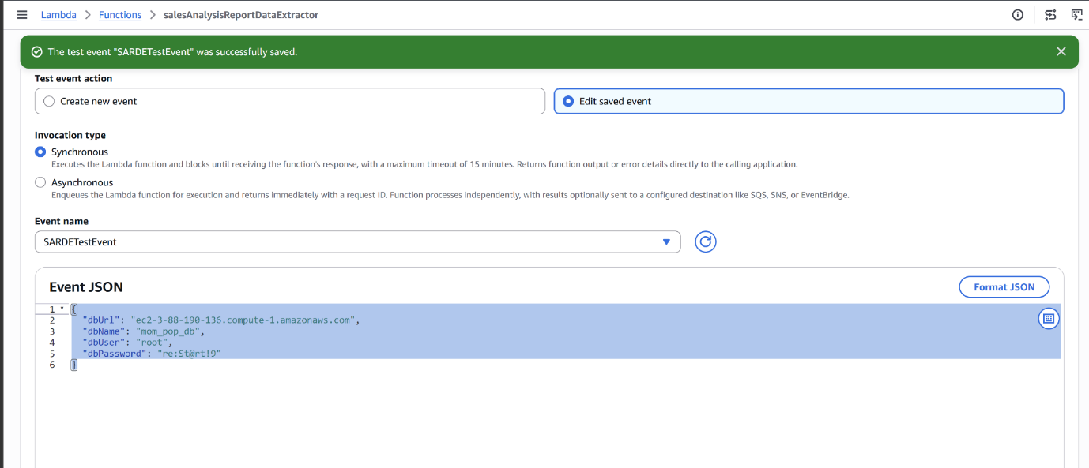

Troubleshooting the data extractor Lambda function
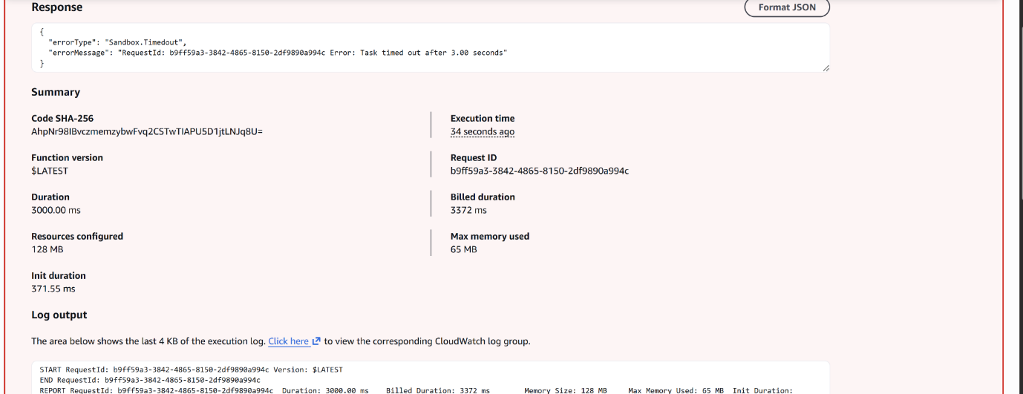

Lambda function troubleshooting challenge
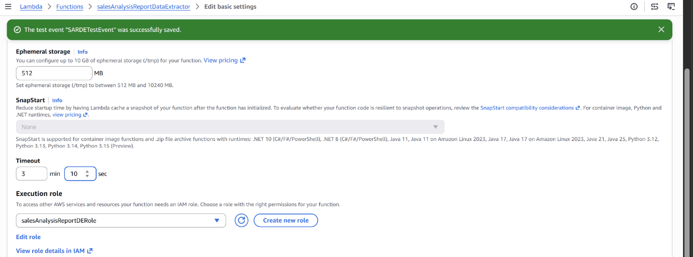

The Fix
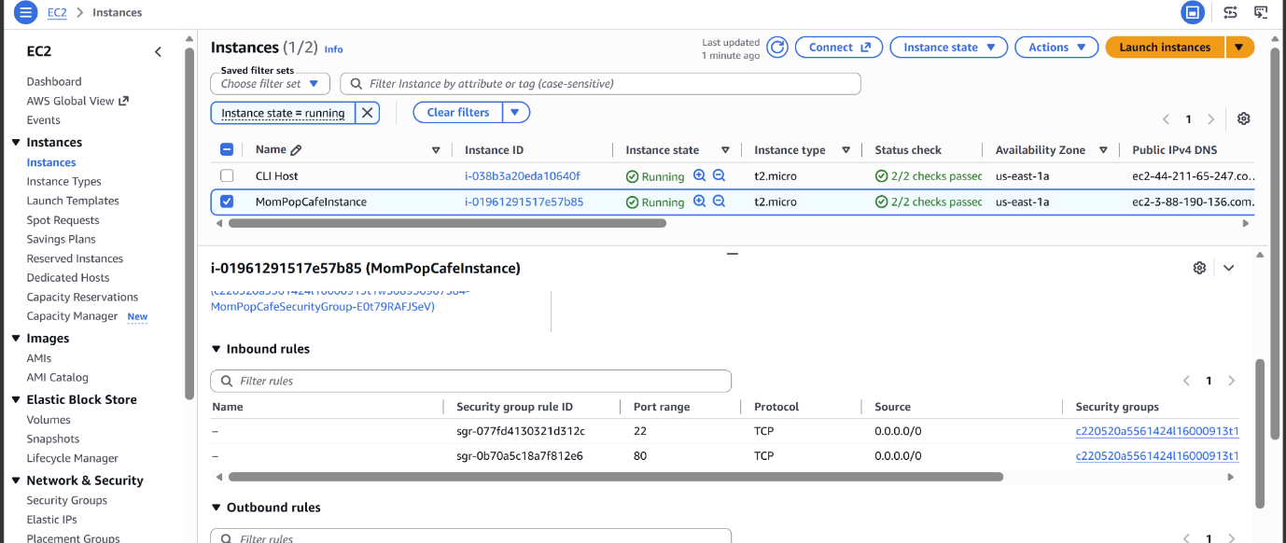

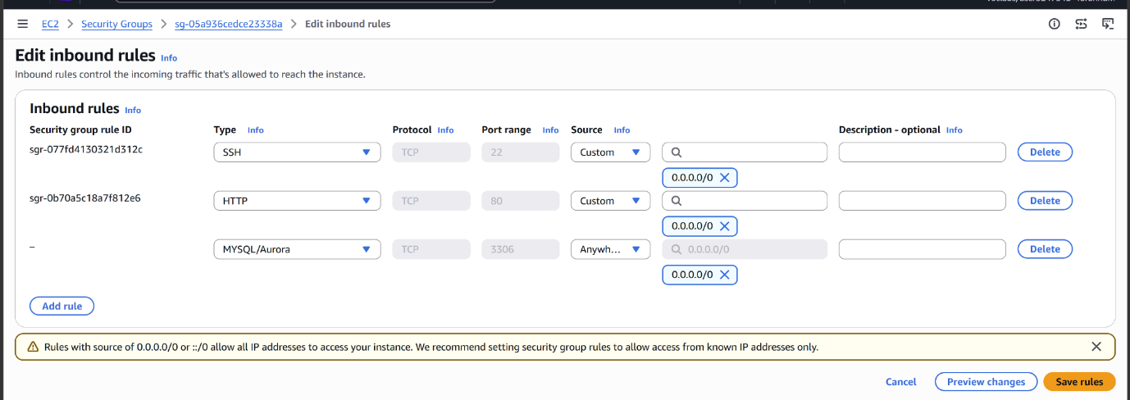

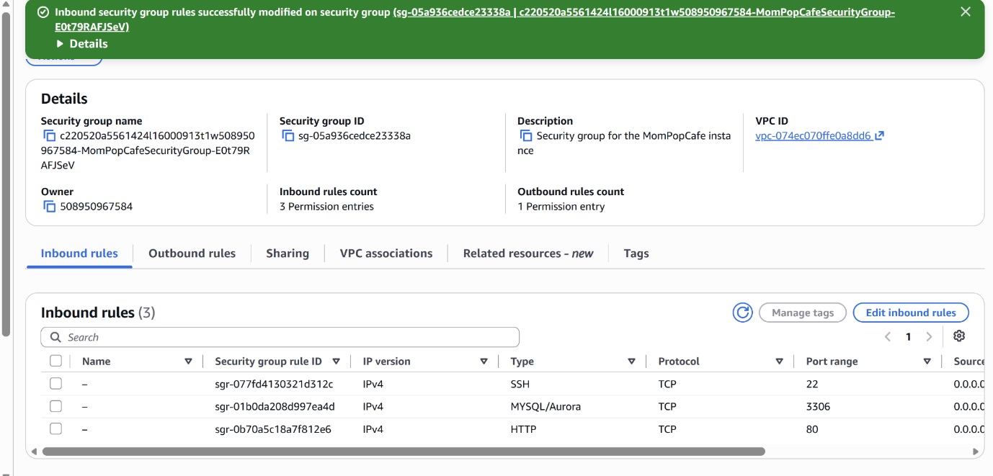

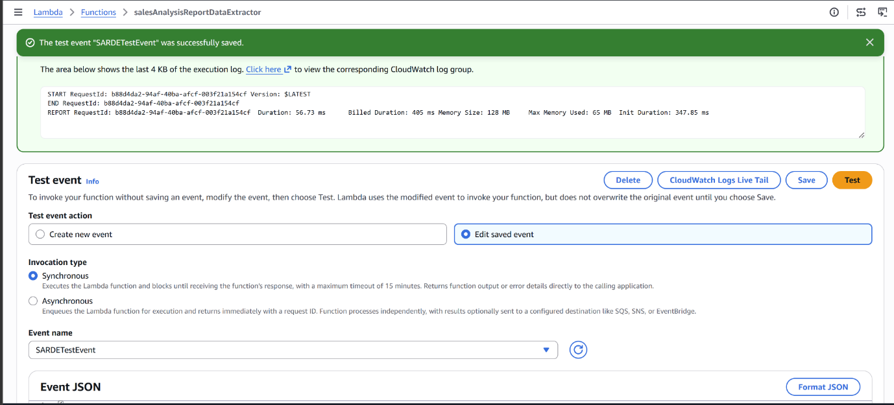

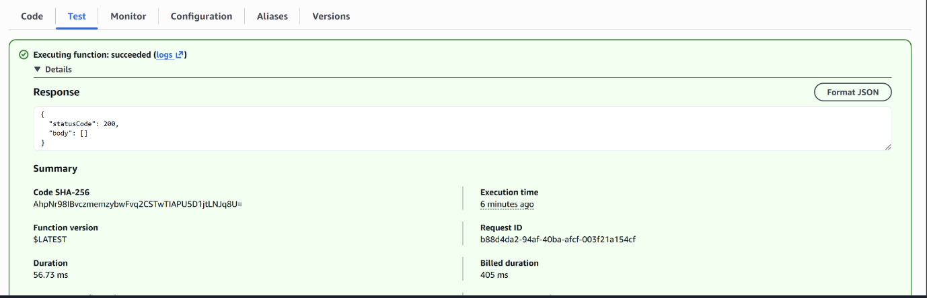

Notice that the body field, which contains the report data extracted by the function, is empty. This is because there is no order data in the database

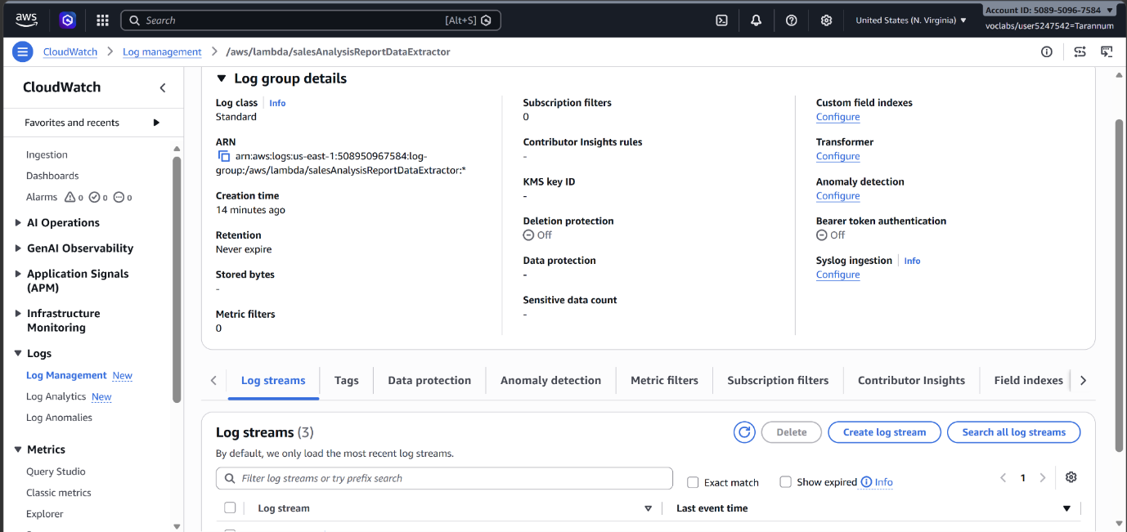

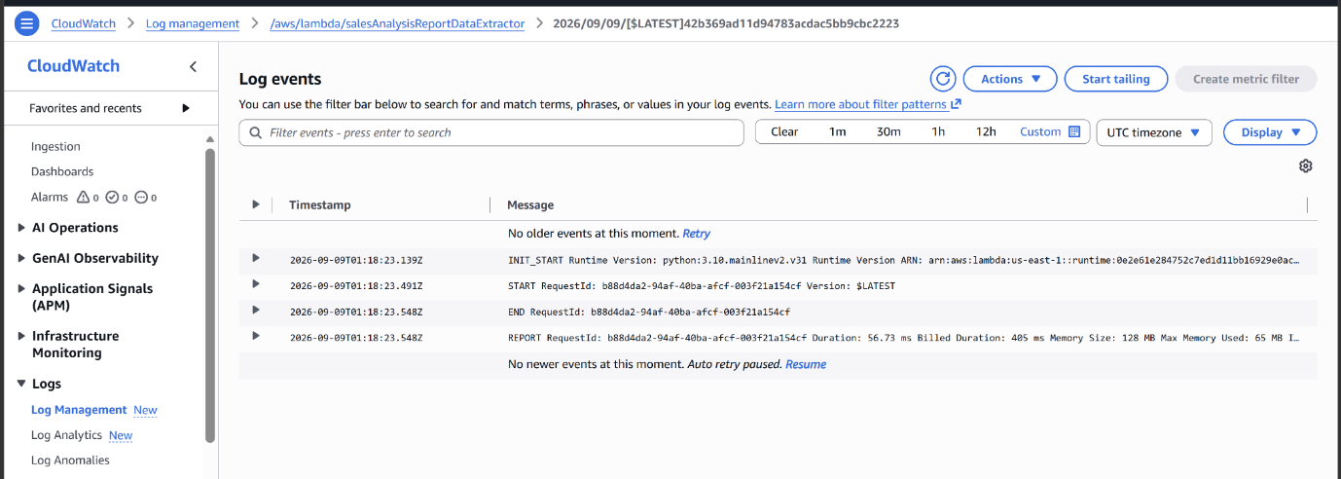
Lambda function has successfully connected to the MySQL database on port 3306 and processed the request.

Place an order and test again
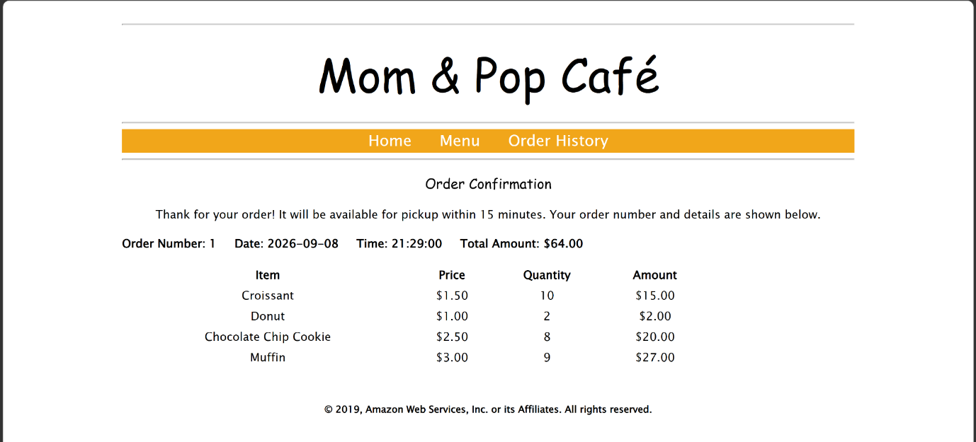

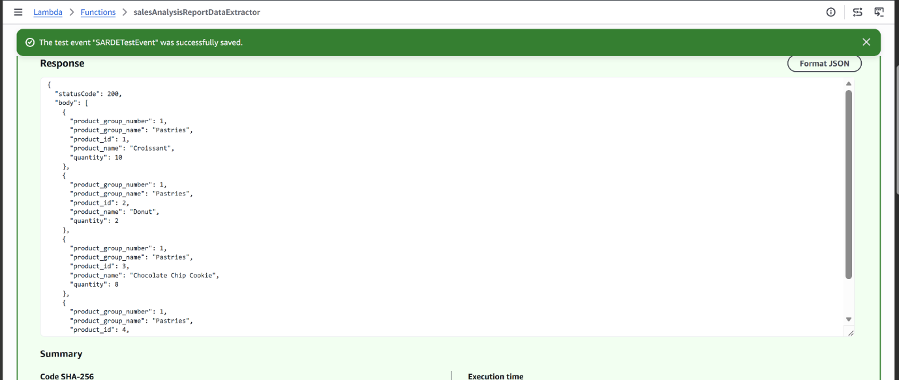

Configure notifications
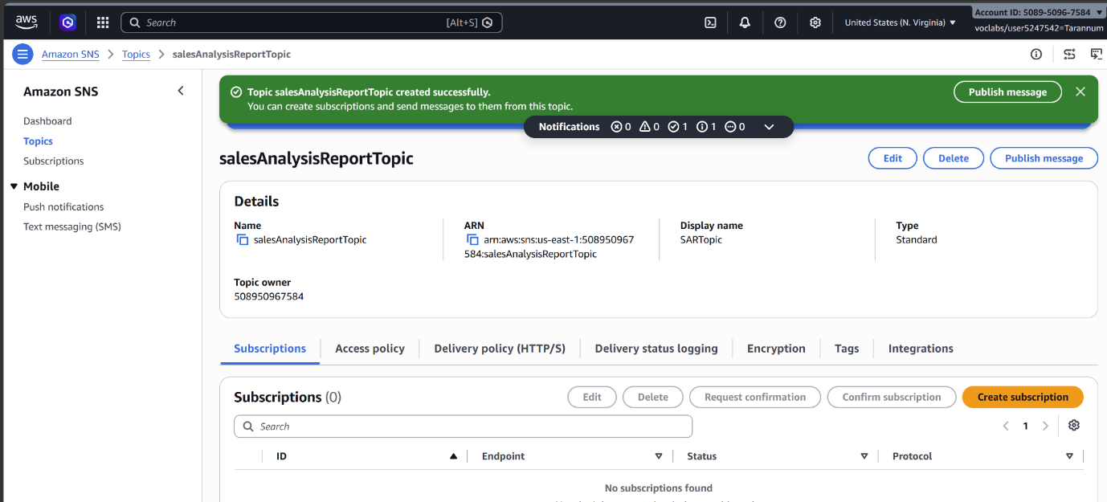
arn:aws:sns:us-east-1:508950967584:salesAnalysisReportTopic
Subscribe to the SNS topic
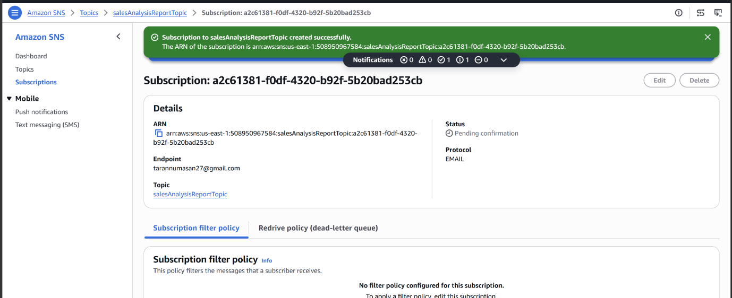

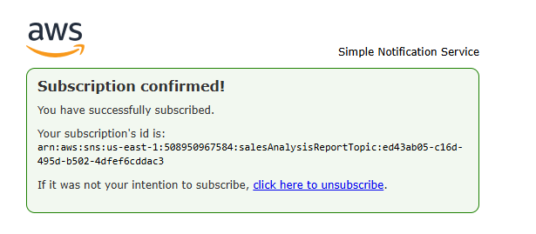

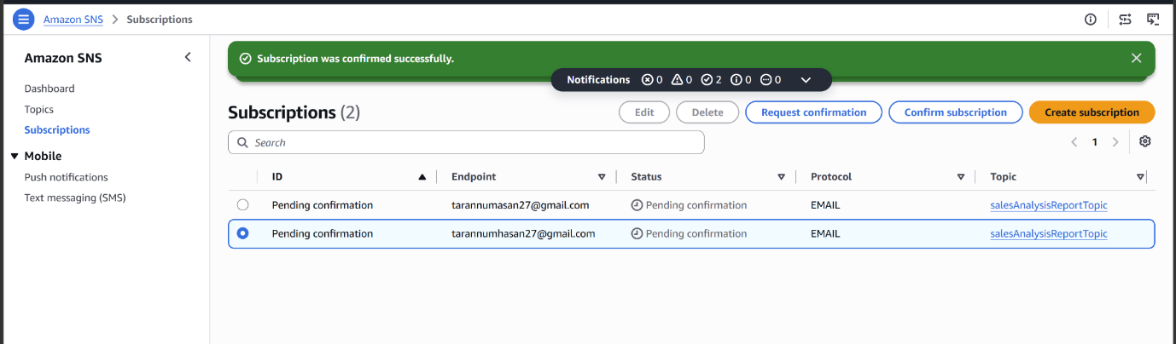
Create the sales analysis report Lambda function
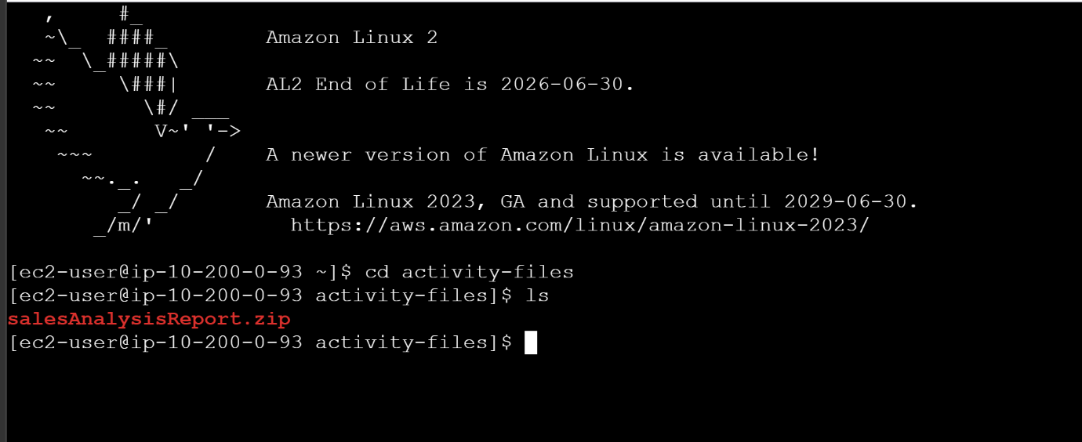

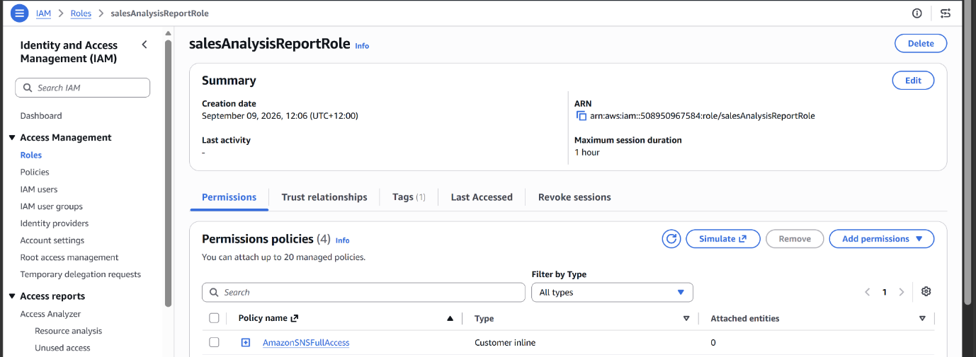

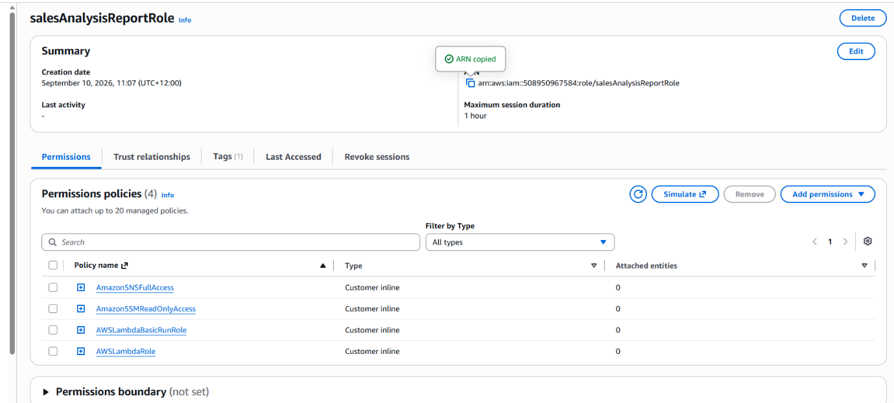

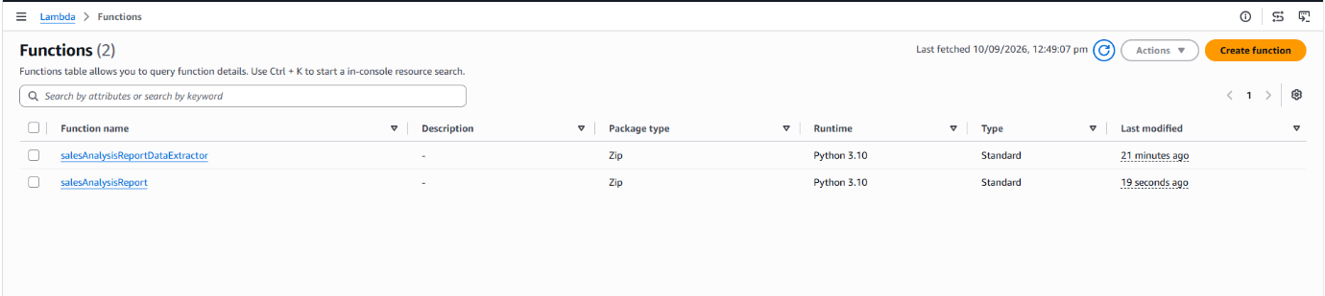

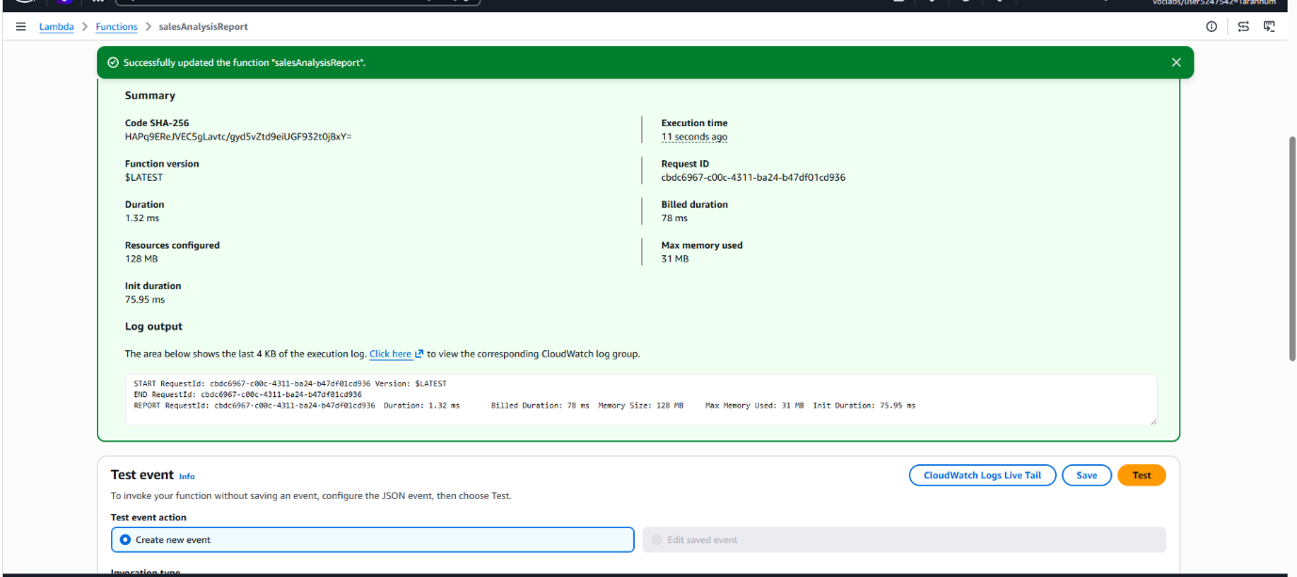

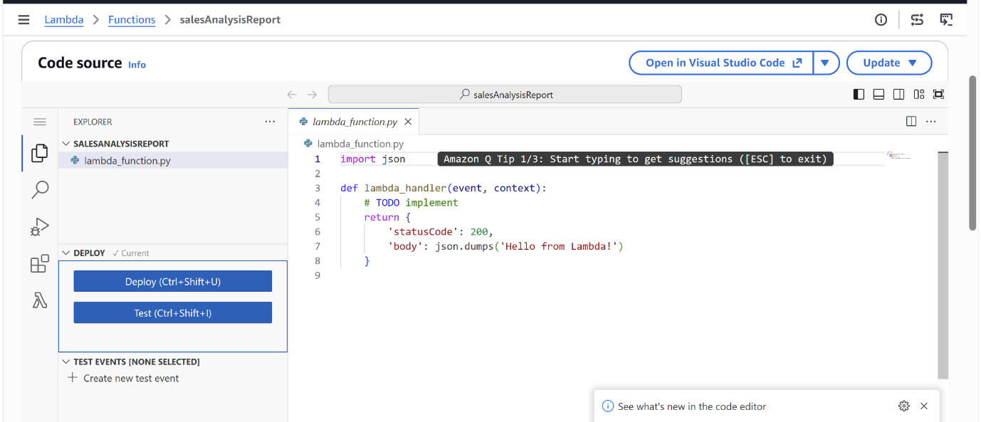

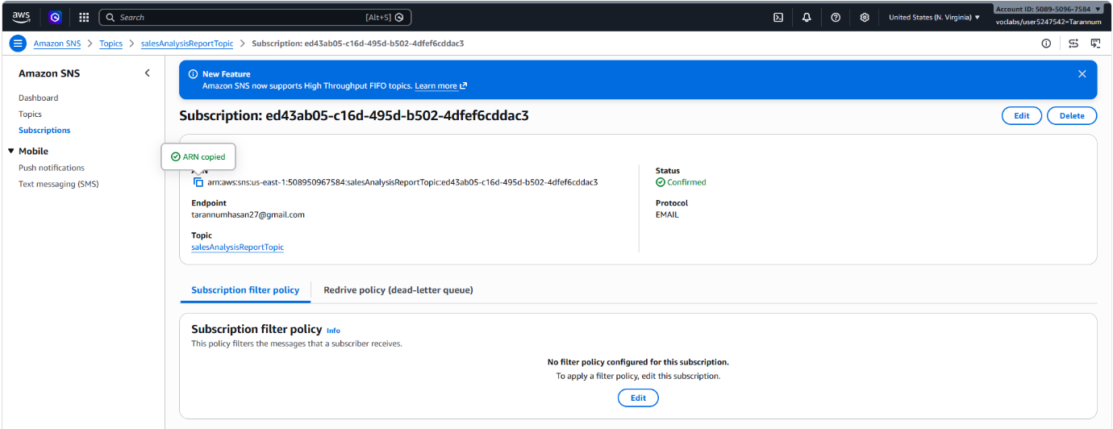

arn:aws:sns:us-east-1:508950967584:salesAnalysisReportTopic:ed43ab05-c16d-495d-b502-4dfef6cddac3

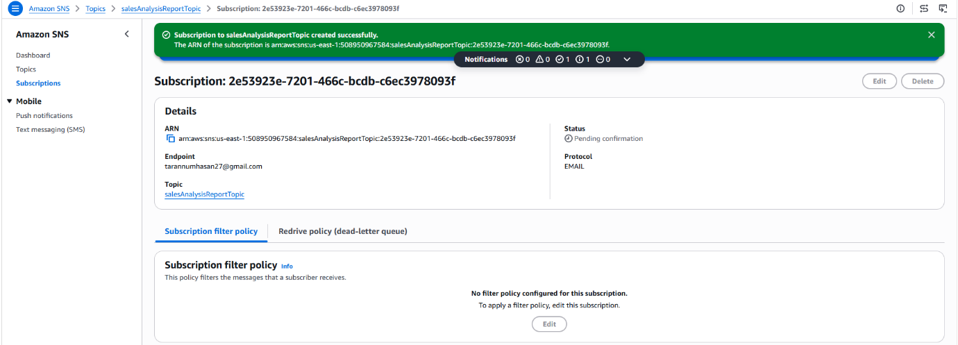

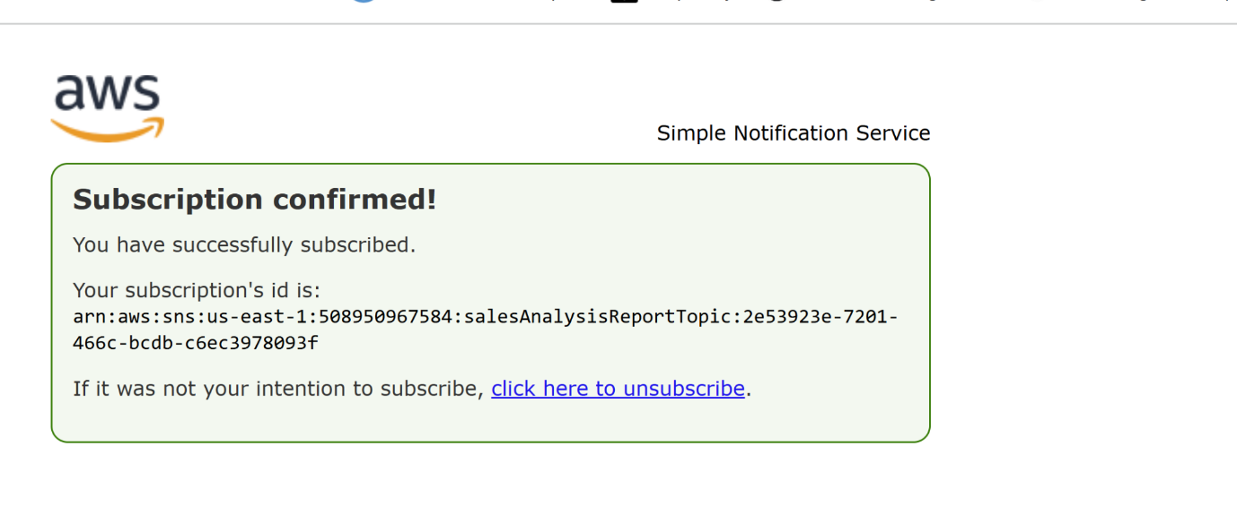

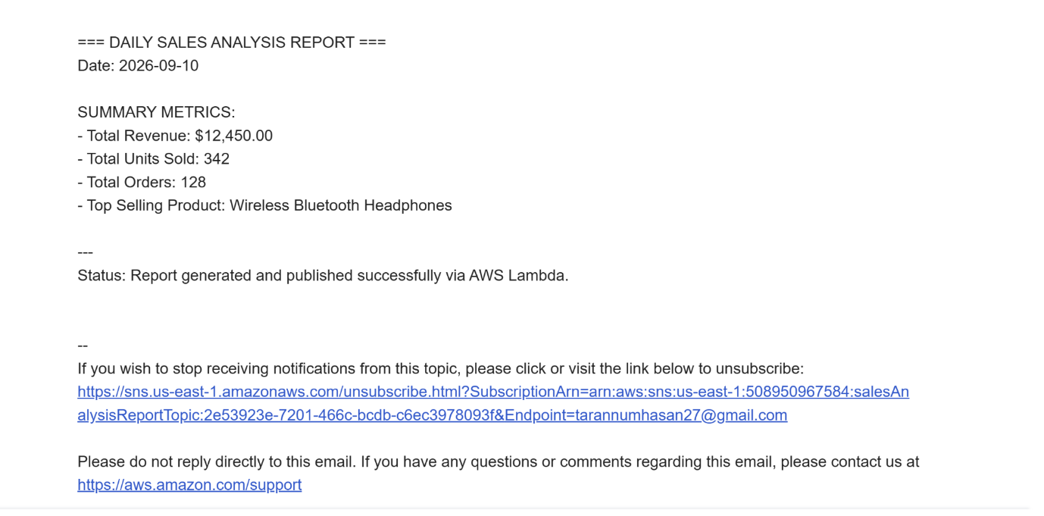
Mail received
Add a trigger to the salesAnalysisReport Lambda function
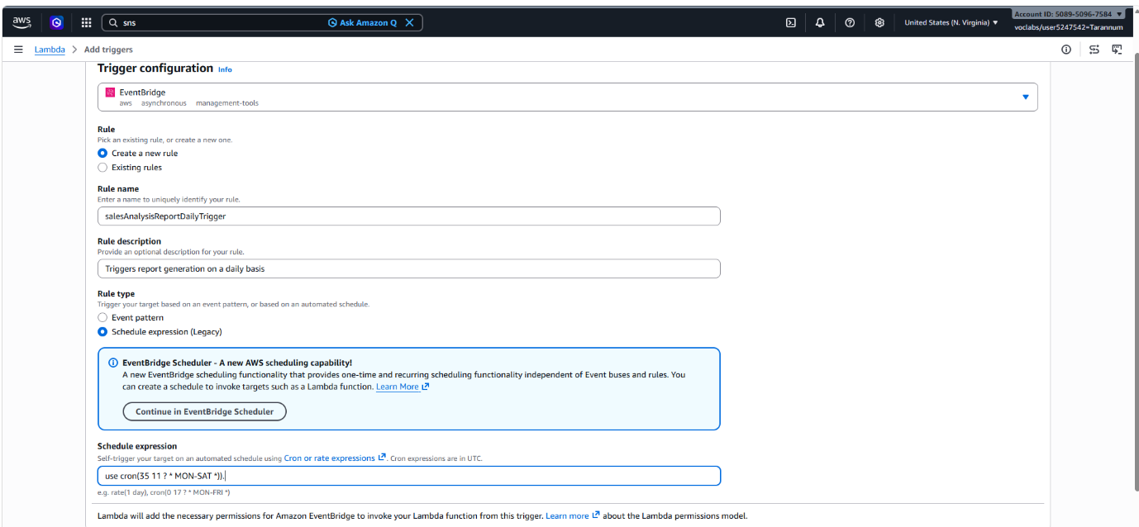
cron(35 11 ? * MON-SAT *)
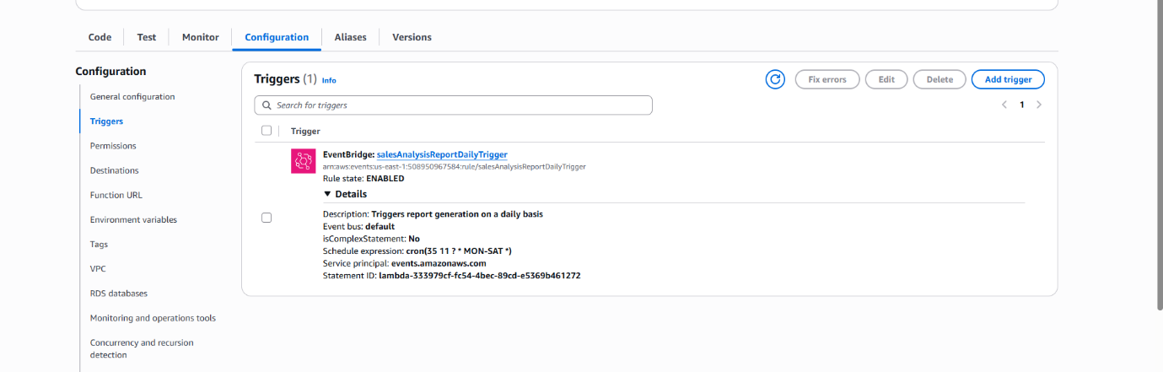
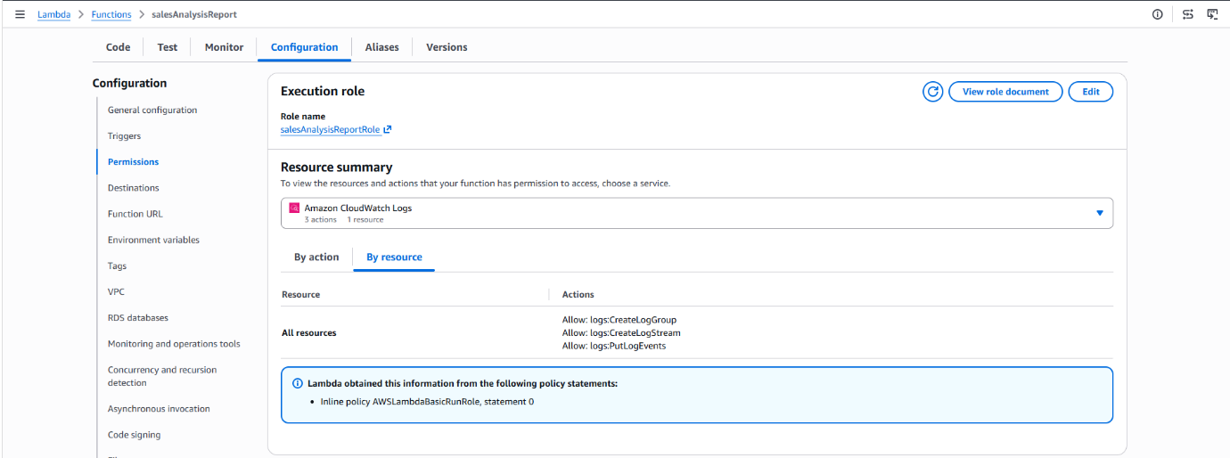
The report would be generated

